

**COMPUTER ENGINEERING**

**DS ODD SEM 2021-22/EXPERIMENT 3 NAME:- GAURAV AMARNANI (D7A, 67)**

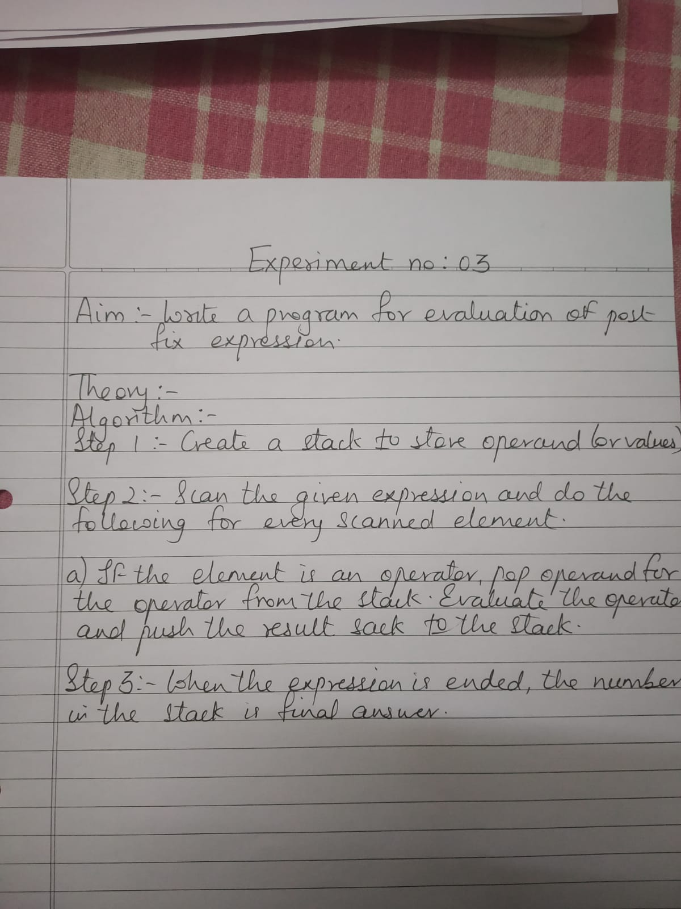

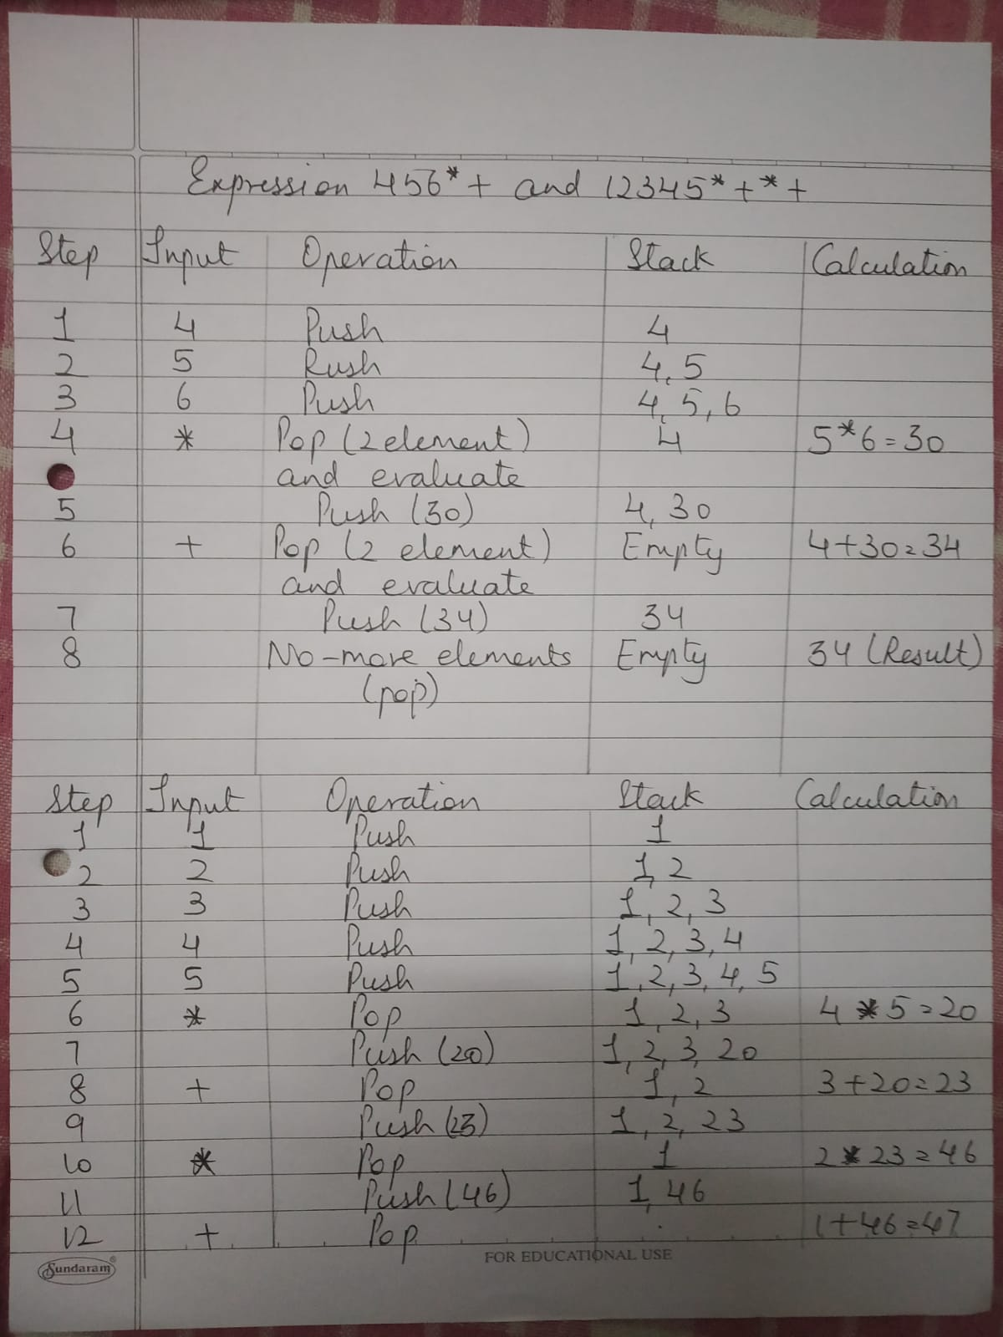

**PROGRAM:**

#include<stdio.h>

int stack [20];

int top=-1;

void push(int x) {

stack [++top] = x;

}

int pop() {

return stack[top--];

}

void main() {

char exp[20], *temp;

int n1, n2, n3, num;

setbuf(stdout, NULL);

printf("Enter postfix expression without space :: ");

scanf("%s", exp);

temp = exp;

while(*temp != '\0') {

if(isdigit(*temp)) {

num = *temp - 48;

push (num);

}

else {

n1 = pop(); //operand1

n2 = pop(); //operand2

switch(*temp) {

case '+': {

n3 = n2 + n1;

break;

}

case '-': {

n3 = n2 - n1;

break;

}

case '*': {

n3 = n2 * n1;

break;

}

case '/' : {

n3 = n2 / n1;

break;

}

}

push(n3);

}

temp++;

}

printf("\nThe result of postfix expression %s = %d\n\n", exp, pop());

}

OUTPUT:-

